**Training Opportunity**

**Incident Command System (ICS 300) Training**

**Date:**Tuesday June 3rd and Wednesday June 4th, 2025

**Time:** 8am-4:30pm

**Location:** 105 E. Main St., Dover-Foxcroft, ME 04426 (2nd floor of the fire station)

Piscataquis County Emergency Management Agency is excited to announce we will be hosting ICS 300, Instructed by Kenneth Latham. This course provides training for personnel who require advanced application of the Incident Command System (ICS). This course expands upon information covered in the introductory ICS courses.

Upon completion of this course, students will be able to:

* Describe how the National Incident Management System Command and Management component supports the management of expanding incidents.
* Describe the Incident/Event Management process for supervisors and expanding incidents as prescribed by the ICS.
* Implement the Incident Management process on a simulated, Type III incident.
* Develop an Incident Action Plan for a simulated incident

**\*The target audience for this course includes individuals who may assume a supervisory role in incidents.**

**Prerequisites:** [ICS-100](https://training.fema.gov/is/courseoverview.aspx?code=IS-100.c&lang=en), [ICS-200](https://training.fema.gov/is/courseoverview.aspx?code=is-200.c&lang=en), [IS-700](https://training.fema.gov/is/courseoverview.aspx?code=IS-700.b&lang=en), [IS-800](https://training.fema.gov/is/courseoverview.aspx?code=IS-800.d&lang=en)

This course is offered free of charge and lunch will be provided. Course materials will be provided unless you request them to be sent to you electronically.

**For more information, contact:** Maureen Conley @ 207-564-8660 or [mconley@piscataquis.us](mailto:mconley@piscataquis.us)

**Scan QR code for registration or follow this link:**

<https://forms.office.com/r/f786LA1iUW>

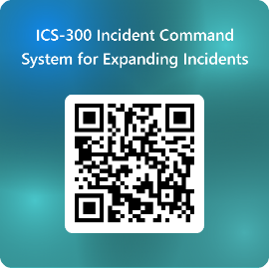

**Please register for the class by May 20, 2025**

Piscataquis County Emergency Management Agency

